**Test Strategy**

# Introduction (High level summary report)

## We are planning to perform automation testing in this project in order ensure quality standards. Here, we will be carrying out both functional and non-functional testing. Our aim is to ensure quality in all phases of the development lifecycle to deliver a great experience for our clients.

# References

Relevant links and helpful information about the project and its tech stack

* Project-Webpage link: <https://www.urbanladder.com/>
* Module to be tested: Living (Module)
* Github-Url:

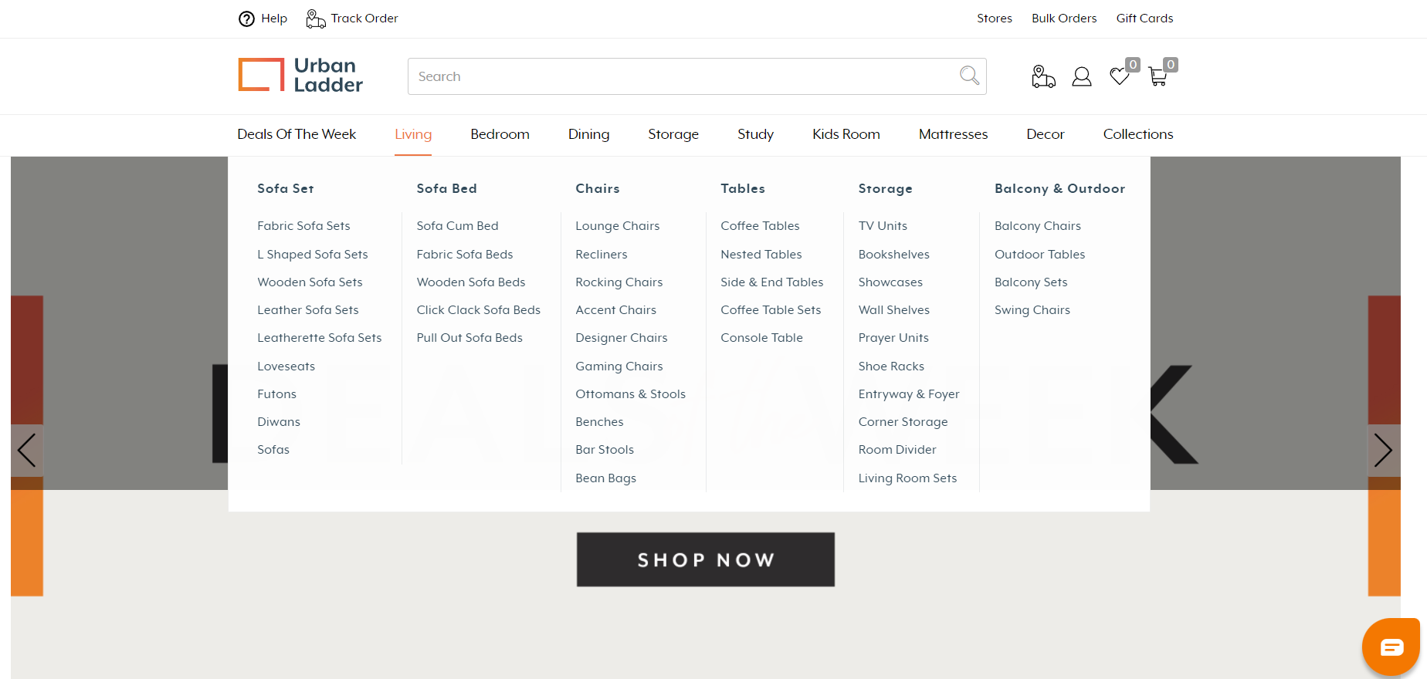

# Details

In this module, we will be testing the webpage using multiple testing tools and frameworks. We are going to perform web-automation testing and evaluate each and every feature or functionality of this module using these below mentioned tools or frameworks.

**Tools to be used:**

* Cypress
* Selenium
* Cucumber
* Junit
* Jenkins(For server deployment readiness)
* Jmeter(For performance and load check
* Appium(For mobile based testing)
* Lighthouse/Axe tools(For meeting quality standards)
* Hybrid frameworks

# QA Deliverables

* Test plans for each feature.
* Issues reported for bugs, enhancements, usability suggestions.
* Automation testing scope.
* Webpage should take less time to load.
* All the major functionalities to be checked properly and thoroughly.
* Update timelines frequently if the tests fail.
* Industry standards need to maintained.
* Web content accessibility guidelines should be practiced.
* Performance and Load testing to check the efficiency of built page.
* Webpage should be compatible to any device. Ex: Laptop, Mobile Etc.
* Testing until UAT at the end of each sprint.
* Test-cases should be executed and organized properly.
* Webpage content needs to be safe and secure.

# Test Management

* Cypress framework is used for front-end webpage testing.
* Selenium tool for automation web-testing.
* Jenkins is used to build test versions of the application.
* Jmeter is used for Performance and Load testing.
* Appium tool is used for mobile compatibility testing.
* Multi browser testing and Cross browser testing.
* NodeJS environment based built tools.
* Unit testing -> Integration -> User acceptance testing for each sprint in agile.
* Cucumber BDD framework for software testing(Feature, Runner, Step def).
* Right software versioning needs to be configured.
* Hybrid frameworks testing needs to be carried out.
* VMs are used to test the applications for testing software in various environments.
* Project management, Test management and Bug management.
* Supported operating systems.
* Test data will include user accounts.
* Proper test data should be used while testing.

# Scope of Testing

* There are unit tests, 50% coverage, written in Cypress, Selenium and Cucumber.
* Written during testing phase—by testing.
* Unit tests are also written using various tools like Junit, Selenium, Cypress and Cucumber.
* Integration tests are also written in Cypress and selenium.
* Each sprint needs run until UAT, So we use tools like selenium and Cypress.
* Manual testing scope for features which can’t be automated.
* Automation scope needs to defined.
* Automated UI tests for high-level workflows.